# **Name: Abdurrahman Qureshi**

# **Roll No: 242466**

Assignment No: 1

**1) Write a Python program using the re module to check if a given string starts with the letter 'A'**

CODE:

import re

x = "Death is an old friend."

y = "Arthur, where are you?"

print(x)

print(re.match("^A",x))

print(y)

print(re.match("^A",y))

OUTPUT:

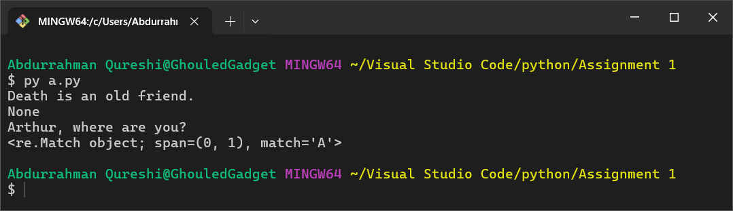

**2) Write a Python program using the re module to extract all digits (0-9) from a given string.**

CODE:

import re

x = "a5sf45asc4a5sf14a5sfd46a8sdf468a1sra5xzc16s5fb468t465314q3d5s1v654h68435zvdc1b6d5b4h68svd"

print(x)

print(re.findall("[0-9]",x))

OUTPUT:

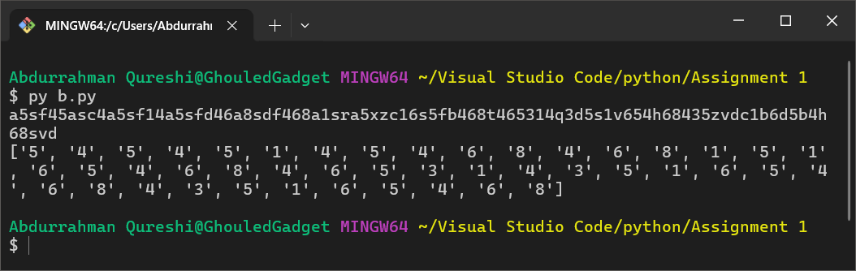

**3) Write a Python program using the re module to check if a given string contains only alphabets (A-Z, a-z) without any numbers or special characters.**

CODE:

import re

x = "CjujgVJGvkgVljcTHvcljHVJGvhgVKUhLIkjbHFXCdsxzHFv"

print(x)

print(re.findall("[a-zA-Z]",x))

OUTPUT:

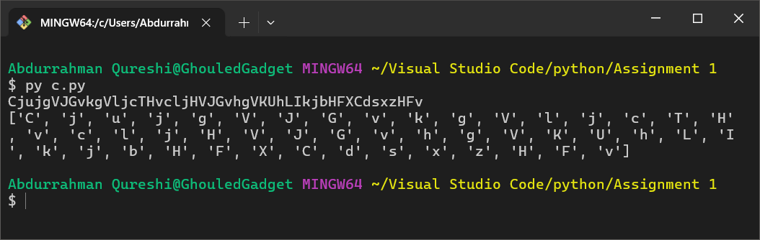

**4) Write a Python program using the re module to check if an input string is a valid email address.**

CODE:

import re

x = "laifnclai"

y = "scythethroughtheheart05@gmail.com"

print(x)

print(y)

print(re.match("[a-zA-Z0-9]+@[a-zA-Z].[a-z]",x))

print(re.match("[a-zA-Z0-9]+@[a-zA-Z].[a-z]",y))

*#*  [a-zA-Z0-9@[a-zA-A-Z].[a-z]

OUTPUT:

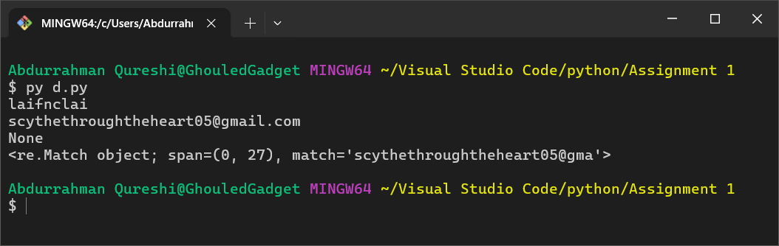

**5) Write a Python program using the re module to check if a word ends with 'ing'.**

CODE:

import re

x = "laisfnvliadfvnliaflaisjnfing"

y = "asjfbahskcvhsadvjhwa"

print(x)

print(y)

print(re.match(".*ing$", x))

print(re.match(".*ing$", y))

OUTPUT:

